Lectio Divina - a Latin term, meaning "divine or sacred reading" describes a way of reading the Scriptures where we gradually let go of our own agenda and open ourselves to what God wants to say to us. There are various ways of practicing Lectio Divina either individually or in groups but most often it’s practiced in four stages.

Stage One | Lectio
Read the passage slowly, out loud, and reflectively. Be thinking about what it says and what it means. What is going on in the passage?

Stage Two | Meditation
Read the passage a second time. Again, carefully and slowly. Be thinking this time about what God is saying to you in the passage. What does he want to reveal to you through the text?

Stage Three | Prayer/Response
The third reading, think about what you want to say to God about the passage and what he’s prompting you with. Let’s your heart respond to God.
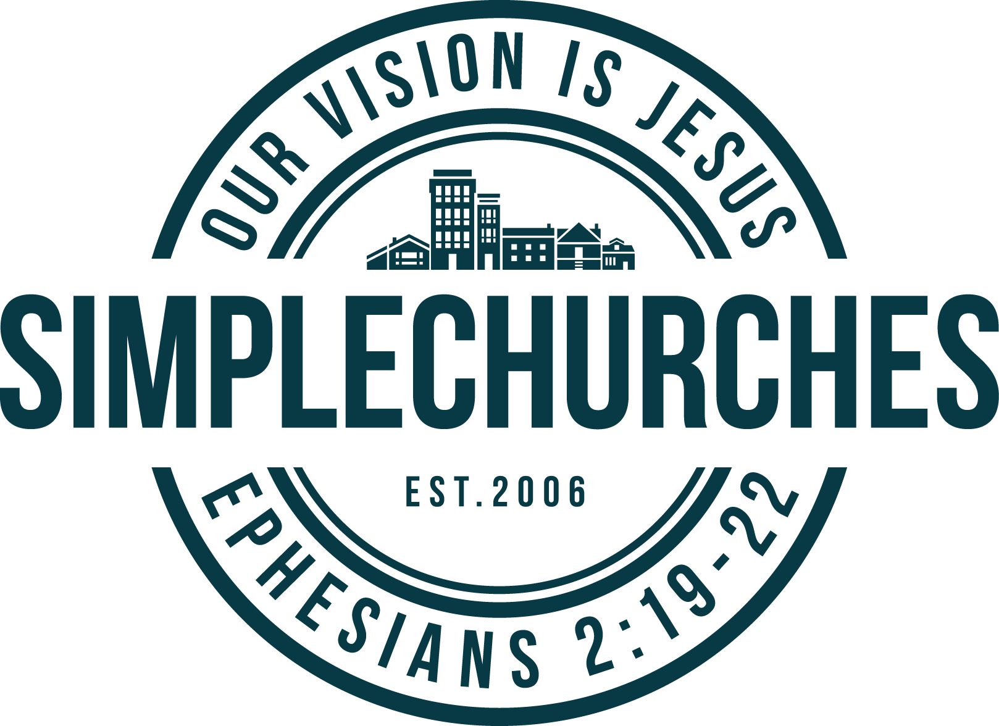
Stage Four | Contemplation
After the fourth reading, we will be quiet. Let go of your own ideas. Simply rest in what God is saying to us through his word.

DISCUSS
After the Lectio, the church can discuss the passage together. The goal here is to understand the text and also to discern what the “Spirit is saying to the church.”

Some questions we might consider:

1. What does the text mean? What is it saying about the nature of God and our relationship to him? What is the context around it?

2. Are there parts of the text that are confusing? Do we need to do more study in the coming week to make sense of what is being said?

3. What was God speaking to you personally about? What were you praying to him about? What was the Spirit illuminating to you as you read?

4. What are the implications of this passage for the church? What is the call to action and change?

